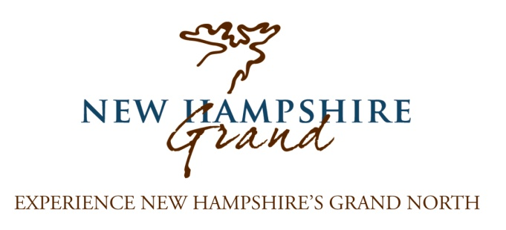
December 6, 2016

Dear Tourism Partner,
Following a “challenging” winter, it was a fantastic summer and fall with all signs pointing towards a successful stretch for tourism in Coos County! NH Grand has shared in this success with website visits increasing 21% over the past 12 months, resulting in nearly 90,000 visits to NH Grand.com!
On the following pages you will find an update on significant projects at NH Grand including our all-new website, brochure initiative and improved advertising efforts. These new initiatives complement our established, ongoing efforts. Please take time to read this information; it truly is a very exciting period for tourism in Northern New Hampshire.
I’m contacting you regarding NH Grand cooperative marketing partnerships for 2017. We rely on your support to provide us the income that we use as matching funds to receive grants which market the region and businesses such as yours. Our partnership opportunities are more affordable than most other promotional organizations in the region, and often cost less than a one-time print ad!
Please review these materials immediately. In order for your business to maximize its partnership benefits, we ask that you respond by January 20, 2017. Once again we will produce a brochure promoting our partners - with distribution of 50k - that we must print and distribute well in advance of the summer season. We also have an ad campaign that will potentially offer increased exposure by getting on board early.
We hope based on the enclosed information, that you see the value in partnering with NH Grand and will be inspired to renew or begin your cooperative marketing partnership for 2017. I encourage you to call me if you have any questions or ideas at (603)-788-2700 x2143.
Thank you in advance for your partnership!
Sincerely,

Katelyn White
Marketing Manager
NH Grand & NCIC

