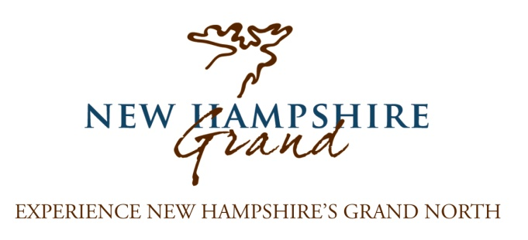
NH Grand 2016 News and Strategic Updates
NHgrand.com: Over the past year we welcomed 75,000 visitors to NHGrand.com, a 35% increase over the prior year! The year before brought an increase of 42%; our audience is growing and we’re building an all-new website to maximize its impact. This growth combined with a modern website will serve as the primary tool for those planning a vacation in northern NH, and those already in the region deciding the next stop on their adventure. In addition to interactive maps featuring partner businesses on the new website, we recently began more prominently featuring links to partner websites. This strategy will continue moving forward, resulting in more quality visits to your website by guests who are actively planning their adventure in Northern New Hampshire!
Grant Awards: We are very fortunate that NH Grand is currently supported by four separate grants for 2016. What this means to your business is the opportunity to benefit from these dollars and the resulting marketing efforts. These grants effectively multiply the spending power of your contribution, we rely on your contributions for the match required to acquire many of these grants.
NH Grand Advertising Initiatives and Map/Brochure: NH Grand will be buying significant targeted online, television and print advertising. Ads will be customized to match specific audiences. Other initiatives include a new map/brochure (35-50k distribution) that we plan to distribute in the state of NH Welcome Centers, trade shows, and other outlets. This brochure will feature a map of the region with your property on the map and in a business directory.
NH Grand Media and Public Relations Efforts: Tens of thousands of potential visitors are reached by a comprehensive, targeted public relations campaign utilizing earned media in national, regional and local outlets, including print, online, television and radio. Over the past 12 month period NH Grand PR efforts have accounted for over $1,700,000 in earned media exposure for our partners. In addition to proactive PR, NH grand is a resource for media seeking assistance on projects. Over the past 12 months the NH Grand office has fielded and responded to nearly 50 media inquiries.
Social Media: Currently NH Grand has over 3,700 likes on Facebook and over 600 people following us on Twitter. We have more than doubled our Facebook following over the past year and hope to quadruple it over the next year through a series of contests and updating news and photos on a daily basis, getting your property in front of a wide audience.
(over)
Grand Views e-newsletter: Distributed monthly featuring our partners, Grand Views give a timely focus on what is happening “now” in the region for the reader. Given the varied offerings of our seasons, this is an invaluable, focused initiative. Over 3,000 people receive Grand Views including previous and prospective visitors. Our Online Connection Newsletter with over 600 recipients is geared toward the region’s businesses and shares news, opportunities, success stories, and more.
Travel Shows: NH Grand is partnering with other regional NH organizations to attend six travel shows in which your business will be represented. Shows include: the NY Times Travel Show, The Great Vacations Expo in Columbus Ohio, Boston Travel Show, AAA Travel Show in Foxboro, MA, Philadelphia Travel Expo, and the Montreal Women’s Travel Show.
Collaboration with state of NH Department of Travel and Tourism: NH Grand consistently works closely with the NH Department of Travel and Tourism ensuring that we fully leverage their powerful marketing efforts including VisitNH.gov (4.8 million page views), NH Visitor’s Guide (130,000 circulation), Public Relations ($26 million in earned exposure), Social Media (Facebook 275,000+ likes, Twitter 21,000+ followers). This past year we hosted a familiarization tour to the region with the Director and Assistant Directors of Travel and Tourism along with the client representative from the state’s advertising agency. Shortly following that visit the state conducted a portion of their 2016 television advertising film shoot throughout Northern NH. Coordinated through NH Grand, Jericho State Park was also featured on the cover of the 2015 State of New Hampshire Visitor’s Guide.
“In the Works”: In the interest of not over-promising specifics to our partners, we do have several projects that are in the fact finding stages. These projects include digital kiosk advertising, media partnership opportunities for larger partners, advertising blocks on NHgrand.com, and the ability to offer printable coupons on NHgrand.com.

