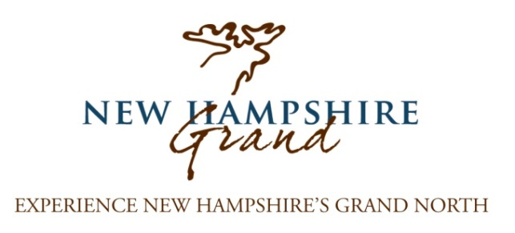

Yes, I would like to become a 2017
New Hampshire Grand Marketing Partner!
RESPOND BY JANUARY 20, 2017 TO MAXIMIZE YOUR BENEFITS!
Please select your level of participation:
Title Partner - $5,000 Signature Event - $1,000
NH Grand Partner - $500 Associate Partner $250
Homepage Advertising Blocks $500 (per month), must be a NH Grand Partner to participate
Ride the Wilds Support - $150 (for members of the Androscoggin Valley Chamber of Commerce, the North Country Chamber of Commerce, Twin Mountain-Bretton Woods Chamber of Commerce, Northern Gateway Chamber of Commerce and Umbagog Chamber of Commerce ) or $250 (non-members)
Please divide my contribution into 2 or 4 (circle one) equal payments and invoice me when payment is due.

Your Name: ________________________________________________________________________
Business Name: _____________________________________________________________________
Address: ___________________________________________________________________________
Business Phone: __________________________________ Cell Phone: _________________________
Email: _____________________________________________________________________________
Website: ___________________________________________________________________________
Social Media Address: Facebook: ____________________ Twitter:____________________
If selecting to partner as a Title Partner, Signature Event*, or Homepage Block Advertiser please list your preferred month(s), dates assigned depend on availability:
1st choice ____________ 2nd choice ____________ 3rd choice ____________
*If becoming a Signature Event we ask you list NH Grand as an event sponsor.
(Over)
Digital requirements:
-For the website and our other materials we need your company logo and any fresh photos of your property. Please provide any quality photos as a JPEG file with minimum dimensions of 1600x1125px. Please send all content via email to: __________
Business Description:
Please provide a very brief description of your business (25 words maximum):
____________________________________________________________________________________
____________________________________________________________________________________

__________________________________ _______________________
Signature Date

Please make checks payable to NCIC and mail to: 1 Middle Street, Lancaster, NH 03584
If you have questions, please contact Katelyn White (603) 788-2700 x2143. THANK YOU!
