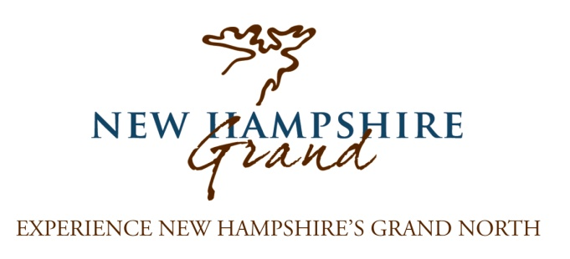
NH Grand 2017 News and Strategic Updates
NHgrand.com: Over the past year we welcomed 89,000 visitors to NHGrand.com, a 21% increase over the prior year! The new website which launched in the New Year introduced a more interactive experience allowing visitors to connect with NH Grand partners easily. This strategy will continue moving forward, resulting in more quality visits to your website by guests who are actively planning their adventure in Northern New Hampshire!
Grant Awards: We are very fortunate that NH Grand is currently supported by four separate grants for 2017. What this means to your business is the opportunity to benefit from these dollars and the resulting marketing efforts. These grants effectively multiply the spending power of your contribution, we rely on your contributions for the match required to acquire many of these grants.
NH Grand Advertising Initiatives: NH Grand will be buying targeted online, television and print advertising. Ads will be customized to match specific audiences. Last year we made a successful move to pay-per-click and social media advertising. This past summer’s campaign drove well over 8k people to NHgrand.com and 1k of those continued to partner websites, our cost per click was $.70. We plan to continue this approach, and improve the message by producing an online recipe book featuring our businesses that will ultimately expand its impact.
Map/Brochure: We will continue our new map/brochure (50k distribution) that we will distribute in the state of NH Welcome Centers, trade shows, and other outlets throughout New England that we expanded to last year. Our 2017 map/brochure is currently on its way to the racks. You will be part of the 2018 map/brochure that we will be developing in the fall of 2017. This brochure will feature a map of the region with your property on the map and in a business directory (at the $500 level and above).
NH Grand Media and Public Relations Efforts: Tens of thousands of potential visitors are reached by a comprehensive, targeted public relations campaign utilizing earned media in national, regional and local outlets, including print, online, television and radio. Over the past 12 month period NH Grand PR efforts have accounted for over $1,900,000 in earned media exposure for our partners. In addition to proactive PR, NH grand is a resource for media seeking assistance on projects. Over the past 12 months the NH Grand office has fielded and responded to nearly 40 media inquiries.
(Over)
Social Media: Currently NH Grand has over 5,500 likes on Facebook (up from 3,700 last year). Our audience has tripled over the past two years. We plan to continue the growth through our advertising campaigns, a series of contests and updating news and photos on a daily basis, getting your property in front of a wide audience.
Grand Views e-newsletter: Distributed monthly featuring our partners, Grand Views gives a timely focus on what is happening “now” in the region for the reader. Given the varied offerings of our seasons, this is an invaluable, focused initiative. Over 5,500 people receive Grand Views (up from 3,000 last year) including previous and prospective visitors. Our Online Connections Newsletter with over 600 recipients is geared toward the region’s businesses and shares news, opportunities, success stories, and more.
Travel Shows: NH Grand is again partnering with other regional NH organizations to attend six travel shows in which your business will be represented. Shows potentially include: the NY Times Travel Show, The Great Vacations Expo in Columbus Ohio, Boston Travel Show, AAA Travel Show in Foxboro, MA, Philadelphia Travel Expo, and the Montreal Adventure Show.
Collaboration with state of NH Department of Travel and Tourism: NH Grand consistently works closely with the NH Department of Travel and Tourism ensuring that we fully leverage their powerful marketing efforts including Visit New England, NH Visitor’s Guide (130,000 circulation), Public Relations ($26 million in earned exposure), Social Media (Facebook 300,000+ likes, Twitter 26,000+ followers). Recently the state conducted a portion of their 2016 television advertising film shoot throughout Northern NH. Coordinated through NH Grand, Jericho State Park was also featured on the cover of the 2015 State of New Hampshire Visitor’s Guide. This past year we coordinated several media FAM trips to the region for the state, and regularly submit information for media requests they fulfill.

