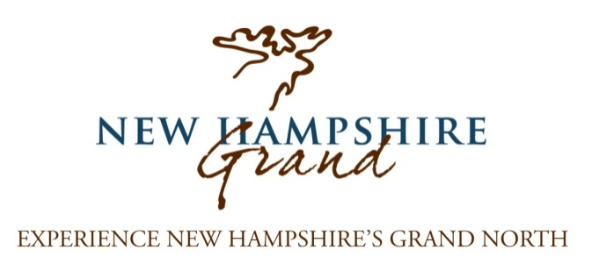
New Hampshire Grand Partnership Opportunities
RESPOND BY JANUARY 20, 2017 TO MAXIMIZE YOUR BENEFITS!

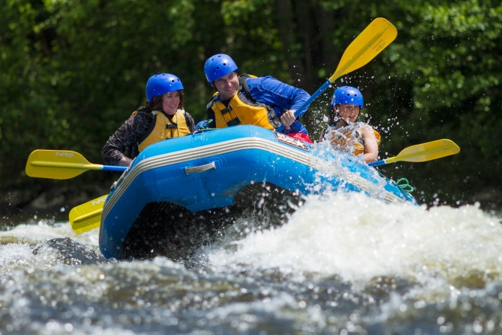
NH Grand Title Partner ($5,000)
By supporting NH Grand at the highest level you will receive the maximum level of exposure available.
Benefits:
-your property’s logo and link to your website at the bottom of every page on NHGrand.com
-homepage featured block presence on NHgrand.com homepage for two months of your choice
-business listing on NHGrand.com with dedicated webpage and online map listing
-featured presence on brochure/map to include locator on map and separate title partner business listing (distribution 50k)
-dedicated video shoot upon request with media b-roll distribution (dependent on availability)
-featured content in a Grand Views e-newsletter
-five focused posts on Facebook, with suggested content provided by partner
-media promotion (TBD: FAM tour and/or Desktop visits)
-preferred placement when relevant, in our monthly media materials and social media campaigns
-representation at the New York Times Travel Show, Boston Travel Show, Great Vacations Travel Expo, AAA Travel Show, Philadelphia Inquirer Travel Expo, and Montreal Adventure Show
-representation at Discover New England Travel Summit
“NH Grand has been a valuable asset to ELC Outdoors- they have helped increase our exposure in online as well televised markets. Web analytics shows a significant amount of traffic is referred from their site as well. They are also easy to work with- prompt and professional!”
-Jim Cochran
ELC Outdoors
NH Grand Partner ($500)
Partnering with NH Grand is an affordable way to ensure your business is part of the region’s #1 marketing initiative.
Benefits:
-business listing on NHGrand.com with dedicated webpage and online map listing
-presence on brochure/map to include locator on map and separate business listing (distribution 50k)
-opportunity to participate in homepage advertising blocks ($500/month, based on availability)
-focused post on Facebook, with suggested content provided by partner
-opportunity to provide events for NHGrand.com events calendar
-preferred placement when relevant, in Grand Views e-newsletter, media materials, and social media campaigns throughout the year
-representation at the New York Times Travel Show, Boston Travel Show, Great Vacations Travel Expo, AAA Travel Show, Philadelphia Inquirer Travel Expo, and Montreal Adventure Show
-representation at Discover New England Travel Summit
“The Androscoggin Valley Chamber of Commerce saw a huge difference in the marketing power of NH Grand with both of our Signature Events in 2015. It contributed to the success of the Jericho ATV Festival and RiverFire by allowing us to reach more potential customers than ever for the money spent. We are looking forward to continuing our partnership with NH Grand in 2016.”
-Paula Kinney
Androscoggin Valley Chamber of Commerce
NH Grand Associate Partner ($250)
We recognize many small businesses have limited marketing budgets; for a minimal investment you can be part of our website, NH Grand’s #1 resource to potential and current visitors.
Benefits:
-business listing on NHGrand.com with dedicated webpage and online map listing
Signature Event ($1,000)
The monthly Signature Event has a bold presence on New Hampshire Grand’s homepage for one month of your choice, offering excellent exposure to all visitors to NHgrand.com.
Benefits:
-featured block for one month on the homepage of NHGrand.com and dedicated page on NHGrand.com
-targeted media campaign promoting event utilizing our MeltWater Media Database (limited availability)
-featured content in a Grand Views e-newsletter (distribution 5k+)
-focused post on Facebook, with suggested content provided by partner, other varied Facebook promotion leading to event
NHGrand.com Homepage Advertising Block ($500/month)
Have your business prominently featured on the homepage of NHGrand.com
Benefits:
-get added exposure during the times that benefit you, to a qualified audience with nearly 90k visits annually (homepage blocks consist of the three square horizontal blocks below the main image)
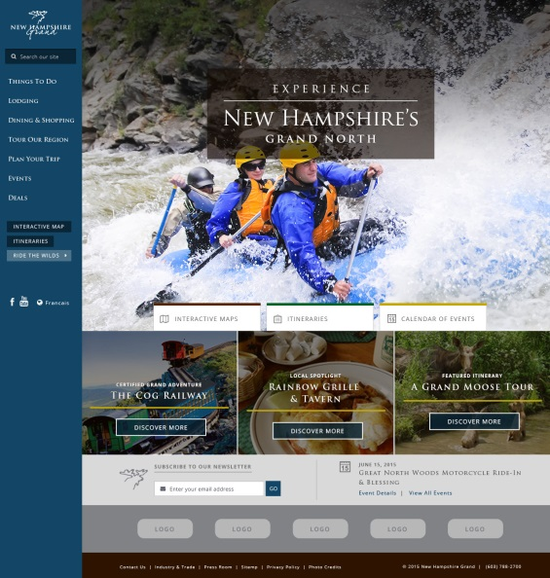
NHGrand.com Redesign

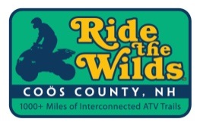
Ride the Wilds Support (optional add-on)
We work closely with the Ride the Wilds ATV trail network and offer your business the opportunity to support Ride the Wilds directly. You will receive signage to proudly display at your property as well as the rights to use the Ride the Wilds logo on your website and promotional materials. These funds are reinvested in marketing Ride the Wilds and the region.
If for any reason none of these options are appealing to your property please contact Katelyn White at NH Grand (603-778-2700 x2143) and we will try to customize a package to fit your needs.
Our goal is to include as many properties and events in Coos County as possible to strengthen our message!

